MECHANICAL STAFF LIST
Name of Teaching Staff | Dr Saurabh Harishchand Gupta |  | 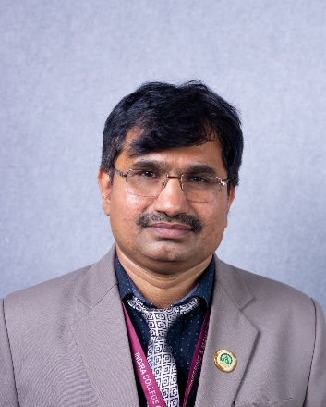
Designation | Professor & Head of the Department
Department | Mechanical Engineering
Qualification with subject & Class / Grade | PhD (Mechanical)
Total Experience in Years | Teaching: 23 | Industrial: Nil | Research: 01
Area of Interest | Refrigeration & Air conditioning, Heat Transfer, Thermodynamics
Research Papers | 10 Journal Papers, 25 Conference Papers

Name of Teaching Staff | Dr. Mahesh G. Bhong |  | 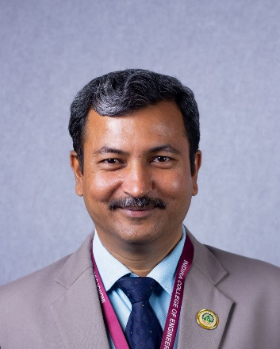
Designation | Associate Professor & Dean R&D
Department | Mechanical Engineering
Qualification with subject & Class / Grade | PhD (Mechanical)
Total Experience in Years | Teaching: 21 | Industrial: Nil | Research: 02
Area of Interest | Heat Transfer, Fluid Mechanics, Automobile Engineering
Research Papers | WOS/ Scopus indexed: 10,  Journal papers: 27,  Conference papers: 24+

Name of Teaching Staff | Dr. Kiran D. Devade |  | 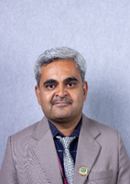
Designation | Professor
Department | Mechanical Engineering
Qualification with subject & Class / Grade | PhD (Mechanical)
Total Experience in Years | Teaching: 22 | Industrial: 01 | Research: 04
Area of Interest | Engineering Graphics, Thermodynamics, Refrigeration, Strength of Materials, Fluid Machinery
Research Papers | WOS/ Scopus indexed: 10,  Journal papers: 27,  Conference papers: 24+

Name of Teaching Staff | Prof. Sushil B.Chopade |  | 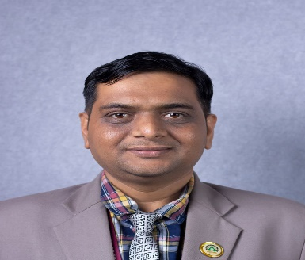
Designation | Assistant Professor & Dean Industry Relation
Department | Mechanical Engineering
Qualification with subject & Class / Grade | Pursuing PhD (Mechanical)  ME (Mechanical Design)  BE (Mechanical)
Total Experience in Years | Teaching: 15+ | Industrial: 2 | Research: 3
Area of Interest | Engineering Metallurgy, Workshop Techology,Dynamics of Machinery,Strength of Material
Research Papers | Scopus Indexed:03;  Patent:01  Journal Papers:10+

Name of Teaching Staff | Prof. Hemant Vasant Darokar |  | 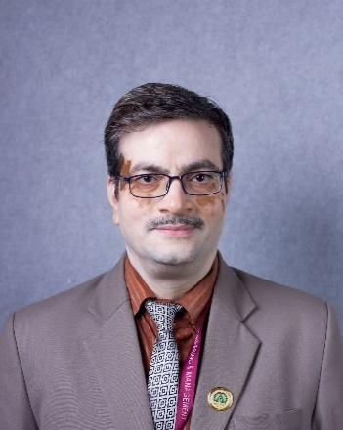
Designation | Assistant Professor & CEO
Department | Mechanical Engineering
Qualification with subject & Class / Grade | ME (Heat Power Engineering) First class with Distinction  BE (Production Engineering) First class with Distinction
Total Experience in Years | Teaching: 16 | Industrial: 7 | Research: 0
Area of Interest | Indirect Evaporative Cooling, Turbomachines, Thermal Engineering
Research Papers | 11

Name of Teaching Staff | Prof. Siddheshwar S. Shirbhate |  | 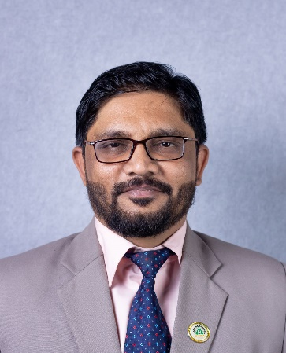
Designation | Assistant Professor
Department | Mechanical Engineering
Qualification with subject & Class / Grade | Pursuing PhD (Mechanical)  ME (Automotive Engineering) First class  BE (Mechanical Engineering) First class
Total Experience in Years | Teaching: 16 | Industrial: nil | Research: 03
Area of Interest | Design, Thermal Engineering
Research Papers | Scopus Indexed:02;  Journal Papers:6

Name of Teaching Staff | Prof. Shubhangi Ashish Manwatkar |  | 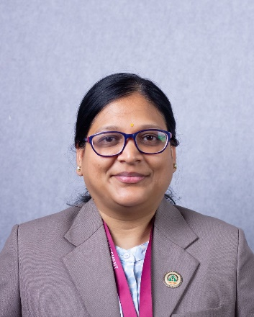
Designation | Assistant Professor
Department | Mechanical Engineering
Qualification with subject & Class / Grade | M.E. (Heat Power) with Distinction,  B.E. (Mechanical) with First Class.
Total Experience in Years | Teaching: 17 | Industrial: 0 | Research: 02
Area of Interest | Heat Transfer, Energy Engineering, Renewable Energy, Energy Managment.
Research Papers | 09

Name of Teaching Staff | Prof. Vishal Abhiman Meshram |  | 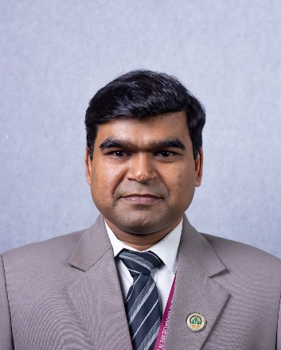
Designation | Assistant Professor
Department | Mechanical Engineering
Qualification with subject & Class / Grade | M.E. (Heat Power) with First Class,  B.E. (Mechanical) with First Class.
Total Experience in Years | Teaching: 15 | Industrial: 01 | Research: 02
Area of Interest | Alternate Fuel, Electric Vehicle, CFD, Heat Transfer, Hydraulics & Pneumatics.
Research Papers | 7

Name of Teaching Staff | Prof. Ashwini Atul Admane |  | 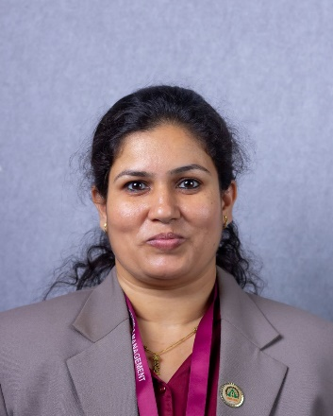
Designation | Assistant Professor
Department | Mechanical Engineering
Qualification with subject & Class / Grade | M.E. (Heat Power) with First Class,  B.E. (Mechanical) with Distinction.
Total Experience in Years | Teaching: 16 | Industrial: 00 | Research: 00
Area of Interest | Thermodynamics, Renewable Energy, Refrigeration.
Research Papers | 05

Name of Teaching Staff | Prof Pranali B Khatake |  | 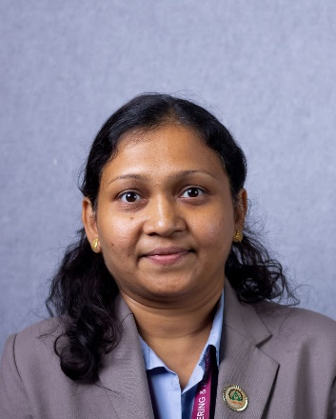
Designation | Assistant Professor
Department | Mechanical Engineering
Qualification with subject & Class / Grade | M.E. (Mech Design) with First Class,  B.E. (Mechanical) with Distinction.
Total Experience in Years | Teaching: 15 | Industrial: 00 | Research: 00
Area of Interest | Design, Vibration.
Research Papers | 08

Name of Teaching Staff | Prof. Ashwini Gaikwad |  | 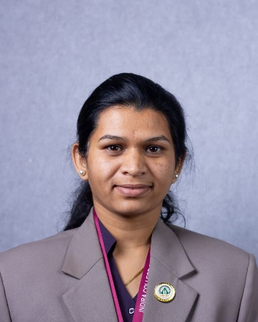
Designation | Assistant Professor
Department | Mechanical Engineering
Qualification with subject & Class / Grade | M.Tech (Automobile) with Distinction.  B.E (Mechanical) with Distinction
Total Experience in Years | Teaching: 11 | Industrial: 1 | Research: 00
Area of Interest | Design, Automotive
Research Papers | 7

Name of Teaching Staff | Prof. Sagar Uttamrao Chirade |  | 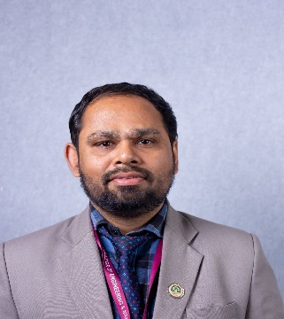
Designation | Assistant Professor
Department | Mechanical Engineering
Qualification with subject & Class / Grade | M.E. (Heat Power) with First Class,  B.E. (Mechanical) with First Class.
Total Experience in Years | Teaching: 14 | Industrial: 00 | Research: 00
Area of Interest | Food drying techniques,Heat Transfer,Fluid Mechanics
Research Papers | 6

Name of Teaching Staff | Prof. Amit Gangadhar Narwade |  | 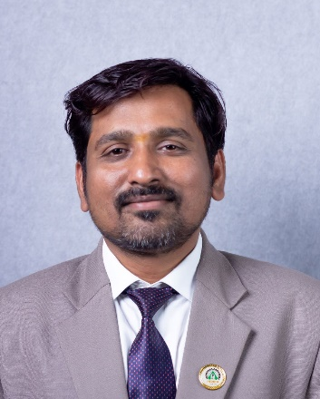
Designation | Assistant Professor
Department | Mechanical Engineering
Qualification with subject & Class / Grade | M.Tech - Automobile (Vehicle Engineering and Transport Management) First Division with Distinction  B.E (Mechanical) First Division with Distinction
Total Experience in Years | Teaching: 09 | Industrial: 01 | Research: 00
Area of Interest | Vehicle Engineering, Safety & Homologation, Engineering Materials.
Research Papers | 05

Name of Teaching Staff | Prof. Pravin Devidas Charde |  | 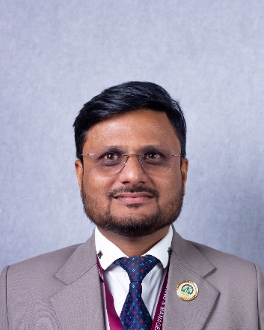
Designation | Assistant Professor
Department | Mechanical Engineering
Qualification with subject & Class / Grade | ME (Mechanical)  BE (Mechanical Sandwich Engineering)  DME(Mechanical)
Total Experience in Years | 18 Years | Industrial: 3 years | Research:
Area of Interest | Manufacturing Process, Workshop Technology
Research Papers | 2

Name of Teaching Staff | Mr. Raj Uttam Gajarmal |  | 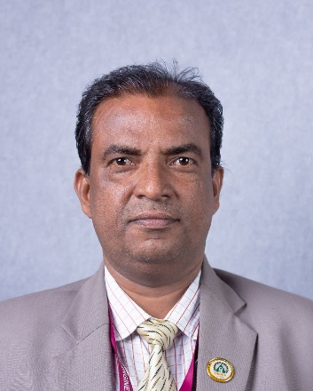
Designation | Workshop Instructor (Fitting Shop)
Department | Mechanical Engineering
Qualification with subject & Class / Grade | ITI (Fitting),  NCTVT
Total Experience in Years | 14 | Industrial: 3 | Research:
Area of Interest | Workshop Technology
Research Papers | --

Name of Teaching Staff | Mr. Manoj Laxman Sutar |  | 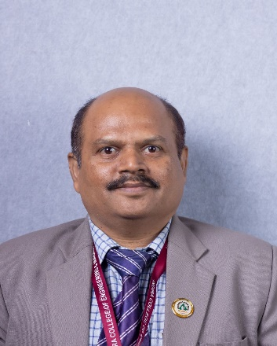
Designation | Workshop Instructor (Welding)
Department | Mechanical Engineerig
Qualification with subject & Class / Grade | ITI (Welding)  NCTVT
Total Experience in Years | 13 Years | Industrial: 6 Years | Research:
Area of Interest | Workshop Technology
Research Papers | --

